**Module-9: Kubernetes Assignment - 2**

You have been asked to:

● Use the previous deployment

● Create a service of type NodePort for nginx deployment

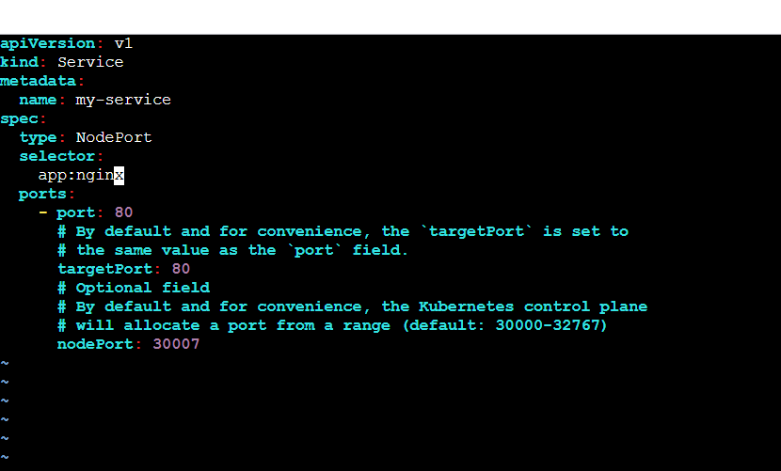

To see the service is created:

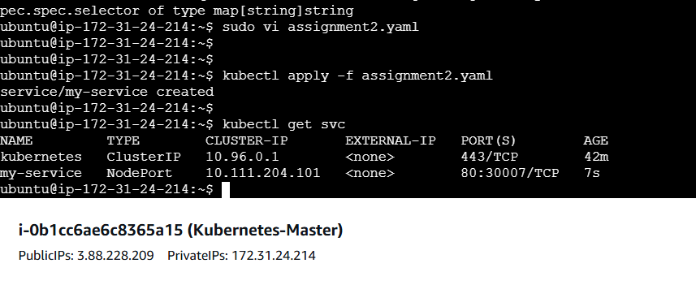

● Check the nodeport service on a browser to verify

Take the Ip address of the slave and give nodeport which we mentioned in yaml file as 30007

On slave1

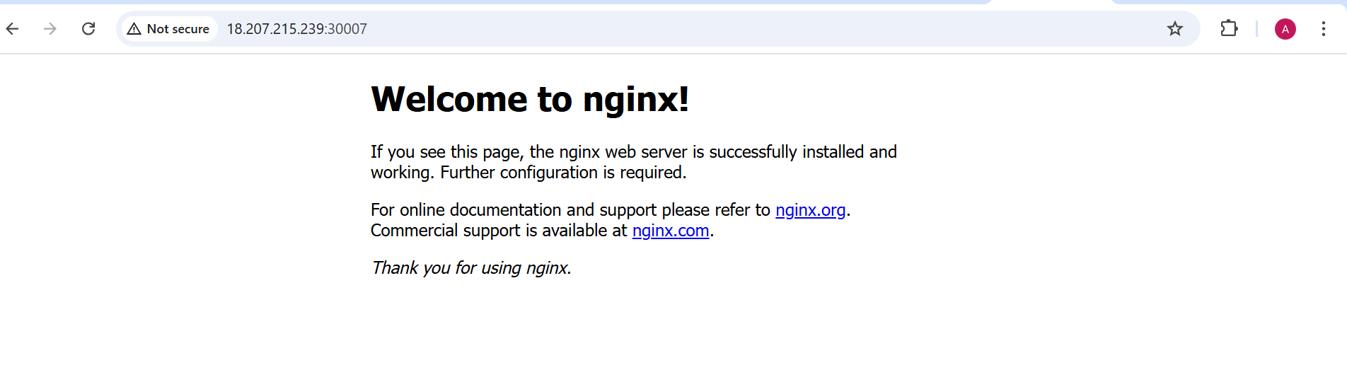

On slave2

